Jenkins?
Jenkins is a software that allows continuous integration. Jenkins will be installed on a server where the central build will take place. The following flowchart demonstrates a very simple workflow of how Jenkins works.
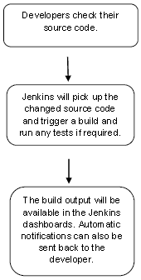

Along with Jenkins, sometimes, one might also see the association of Hudson. Hudson is a very popular open-source Java-based continuous integration tool developed by Sun Microsystems which was later acquired by Oracle. After the acquisition of Sun by Oracle, a fork was created from the Hudson source code, which brought about the introduction of Jenkins.

What is Continuous Integration?
Continuous Integration is a development practice that requires developers to integrate code into a shared repository at regular intervals. This concept was meant to remove the problem of finding later occurrence of issues in the build lifecycle. Continuous integration requires the developers to have frequent builds. The common practice is that whenever a code commit occurs, a build should be triggered.

Continuous Integration is a process of integrating code changes from multiple developers in a single project many times. The software is tested immediately after a code commit. With each code commit, code is built and tested. If the test is passed, the build is tested for deployment. If the deployment is successful, the code is pushed to production.
This commit, build, test, and deploy is a continuous process and hence the name continuous integration/deployment.
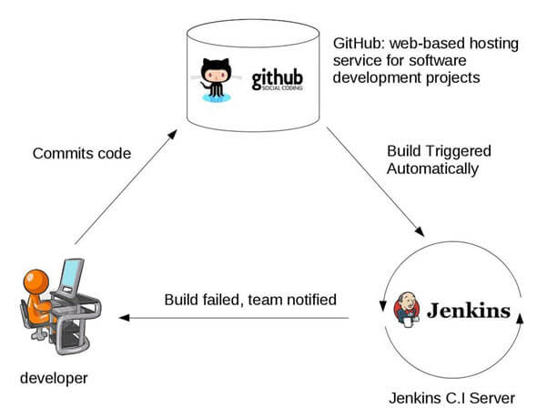

System Requirements
JDK | JDK 1.5 or above
Memory | 2 GB RAM (recommended)
Disk Space | No minimum requirement. Note that since all builds will be stored on the Jenkins machines, it has to be ensured that sufficient disk space is available for build storage.
Operating System Version | Jenkins can be installed on Windows, Ubuntu/Debian, Red Hat/Fedora/CentOS, Mac OS X, openSUSE, FReeBSD, OpenBSD, Gentoo.
Java Container | The WAR file can be run in any container that supports Servlet 2.4/JSP 2.0 or later.(An example is Tomcat 5).

Advantages of using Jenkins
- Jenkins is being managed by the community which is very open. Every month, they hold public meetings and take inputs from the public for the development of Jenkins project.
- So far around 280 tickets are closed, and the project publishes stable release every three months.
- As technology grows, so does Jenkins. So far Jenkins has around 320 plugins published in its plugins database. With plugins, Jenkins becomes even more powerful and feature rich.
- Jenkins tool also supports cloud-based architecture so that you can deploy Jenkins in cloud-based platforms.
- The reason why Jenkins became popular is that it was created by a developer for developers.

Disadvantages of using Jenkins
Though Jenkins is a very powerful tool, it has its flaws.
- Its interface is out dated and not user friendly compared to current UI trends.
- Though Jenkins is loved by many developers, it’s not that easy to maintain it because Jenkins runs on a server and requires some skills as server administrator to monitor its activity.
- One of the reasons why many people don’t implement Jenkins is due to its difficulty in installing and configuring Jenkins.
- Continuous integrations regularly break due to some small setting changes. Continuous integration will be paused and therefore requires some developer attention.
- JENKINS INSTALLATION PROCESS :
Explore the Jenkins Environment
- Explore the Jenkins Environment
: • Once the Jenkins environment is set up, you can explore the various features and functionalities available in the web interface.
• Jenkins has a rich user interface that provides access to features such as build history, build statistics, and system information. These are the basic steps to install and set up Jenkins. Depending on your use case, you may need to customize your Jenkins environment further. For example, you may need to configure build agents, set up build pipelines, or integrate with other tools. However, these steps should give you a good starting point for using Jenkins for CI/CD in your software development projects.

- Jenkins provides a user-friendly web interface for managing projects and jobs. Here are some of the key features of the Jenkins environment:

- Dashboard: The Jenkins dashboard provides an overview of all the projects and jobs currently running.

- Jobs: Jobs are the basic building blocks of Jenkins, and they define a sequence of steps to be executed.

- Build history: Jenkins keeps track of the build history for each job, which can be useful for tracking changes and identifying issues.

- Plugins: Jenkins has a large collection of plugins that can be used to extend its functionality, such as integrating with other tools and services.

- Configuration: Jenkins provides a configuration interface where you can set up projects, jobs, and build environments.

- By exploring these features and customizing the Jenkins environment to your needs, you can create a powerful and flexible CI/CD system for your projects.

Jenkins Architecture
Let us have a look at the Jenkins Architecture below diagram depicts the same.
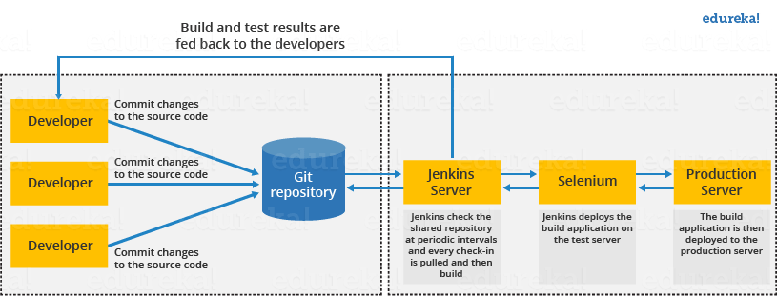
This single Jenkins server was not enough to meet certain requirements like:
- Sometimes you might need several different environments to test your builds. This cannot be done by a single Jenkins server.
- If larger and heavier projects get built on a regular basis then a single Jenkins server cannot simply handle the entire load.
To address the above-stated needs, Jenkins distributed architecture came into the picture.

Jenkins Distributed Architecture
Jenkins uses a Master-Slave architecture to manage distributed builds. In this architecture, Master and Slave communicate through TCP/IP protocol.
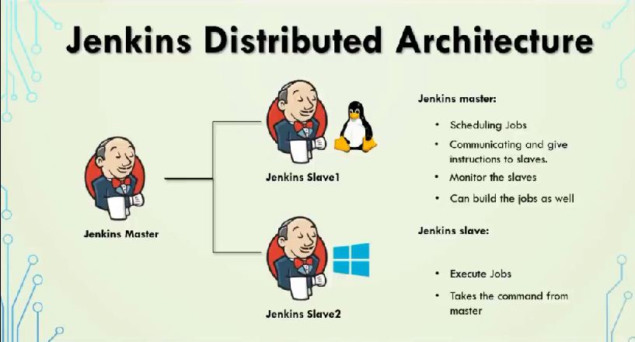

DevOps Ccation Training Course
Explore Curriculum

Jenkins Master
Your main Jenkins server is the Master. The Master’s job is to handle:
- Scheduling build jobs.
- Dispatching builds to the slaves for the actual execution.
- Monitor the slaves (possibly taking them online and offline as required).
- Recording and presenting the build results.
- A Master instance of Jenkins can also execute build jobs directly.

Jenkins Slave
A Slave is a Java executable that runs on a remote machine. Following are the characteristics of Jenkins Slaves:
- It hears requests from the Jenkins Master instance.
- Slaves can run on a variety of operating systems.
- The job of a Slave is to do as they are told to, which involves executing build jobs dispatched by the Master.
- You can configure a project to always run on a particular Slave machine or a particular type of Slave machine, or simply let Jenkins pick the next available Slave.
The diagram below is self-explanatory. It consists of a Jenkins Master which is managing three Jenkins Slave.
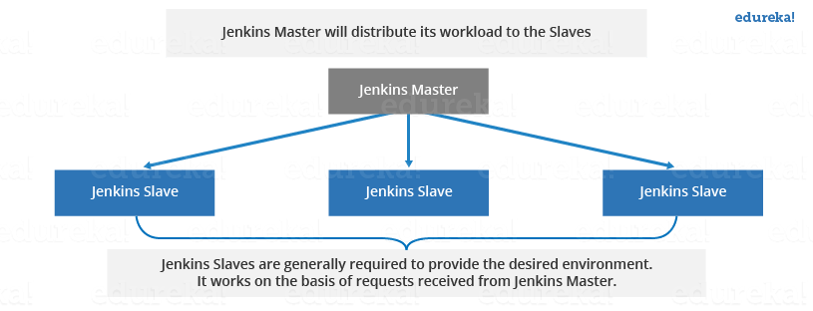

How Jenkins Master and Slave Architecture works?
Now let us look at an example in which we use Jenkins for testing in different environments like Ubuntu, MAC, Windows, etc.
The diagram below represents the same:
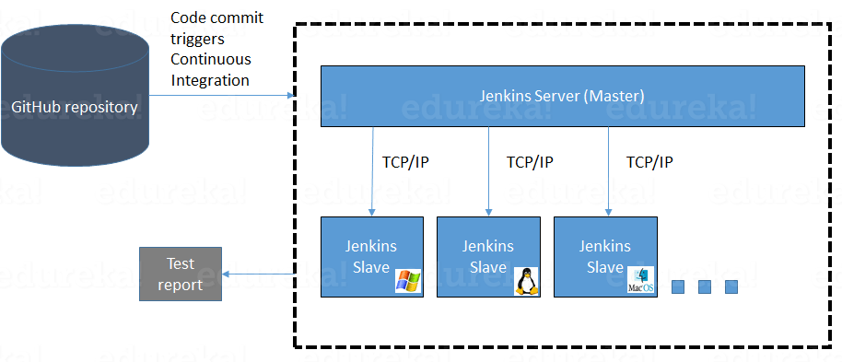
The above image represents the following functions:
- Jenkins checks the Git repository at periodic intervals for any changes made in the source code.
- Each builds requires a different testing environment which is not possible for a single Jenkins server. In order to perform testing in different environments, Jenkins uses various Slaves as shown in the diagram.
- Jenkins Master requests these Slaves to perform testing and to generate test reports.

How to setup Jenkins Master and Slaves?
- Go to the Manage Jenkins section and scroll down to the section of Manage Nodes.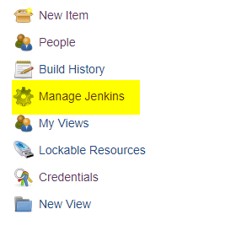

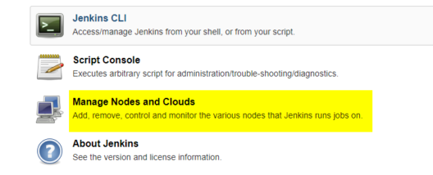

2. Click on New Node
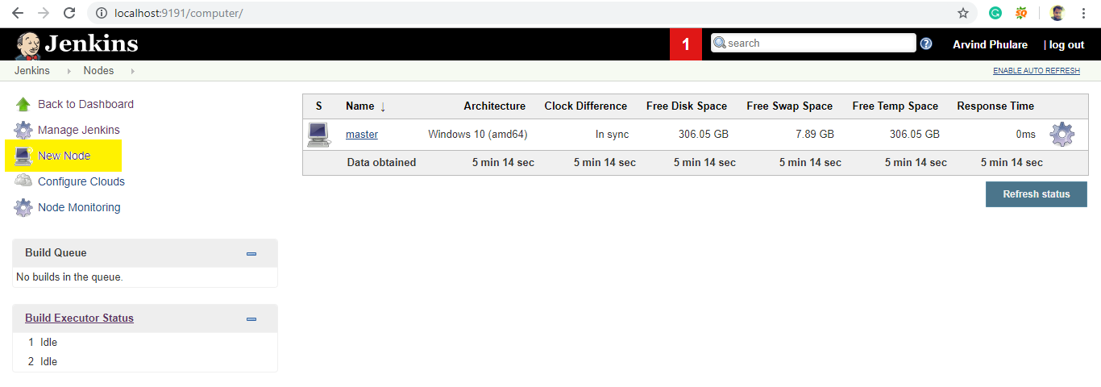3. Give a name for the node, choose the Permanent Agent option and click on Ok.
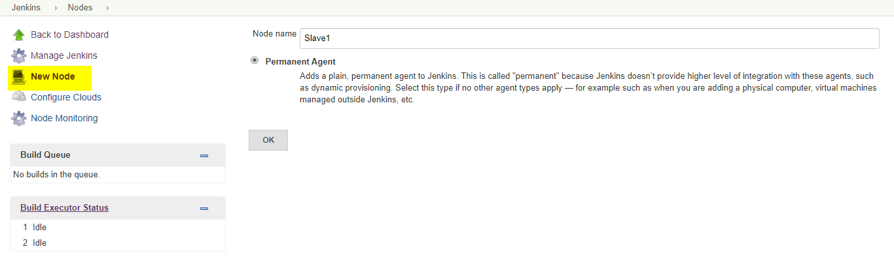4. Enter the details of the node slave machine. Here no. of executers in nothing but no. of jobs that this slave can run parallely. Here we have kept it to 2. The Labels for which the name is entered as “Slave1” is what can be used to configure jobs to use this slave machine.Select Usage to Use this node as much as possible. For launch method we select the option of “Launch agent by connecting it to the master”. If this option is not visible then go to Jenkins home page -> Manage Jenkins -> Configure Global Security. Here in the Agents section click on Random and Save it. Now you will find the required option. Enter Custom WorkDir path as the workspace of your slave node. In Availability select “Keep this agent online as much as possible”.Click on Save.
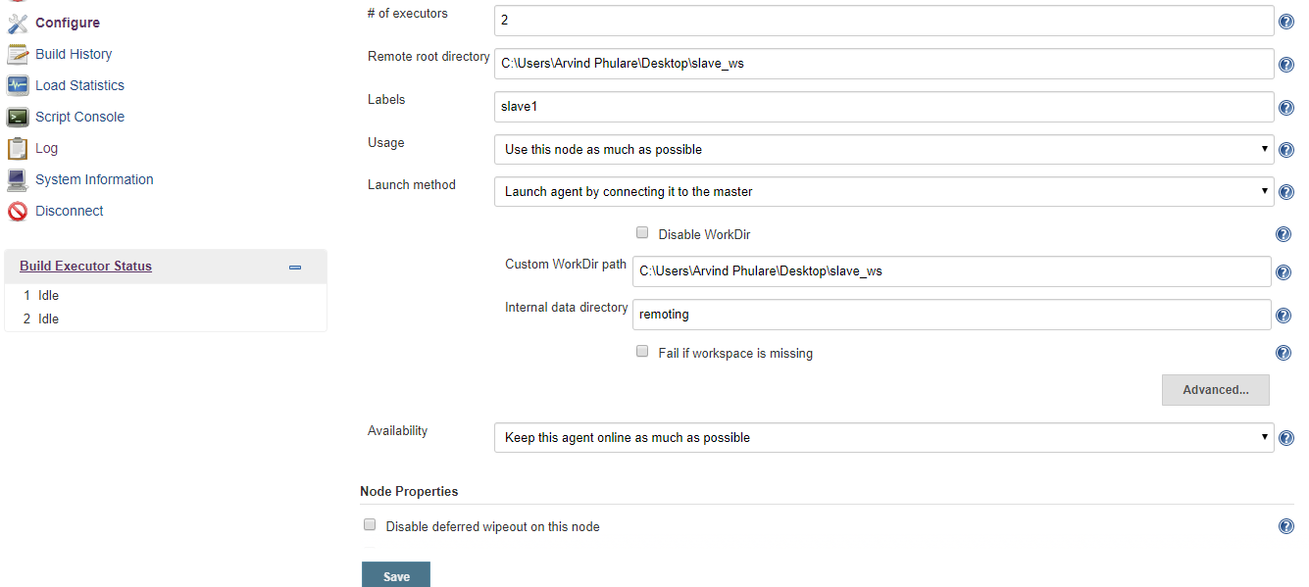
Once you complete the above steps, the new node machine will initially be in an offline state but will come online if all the settings in the previous screen were entered correctly. One can at any time make the node slave machine offline if required.
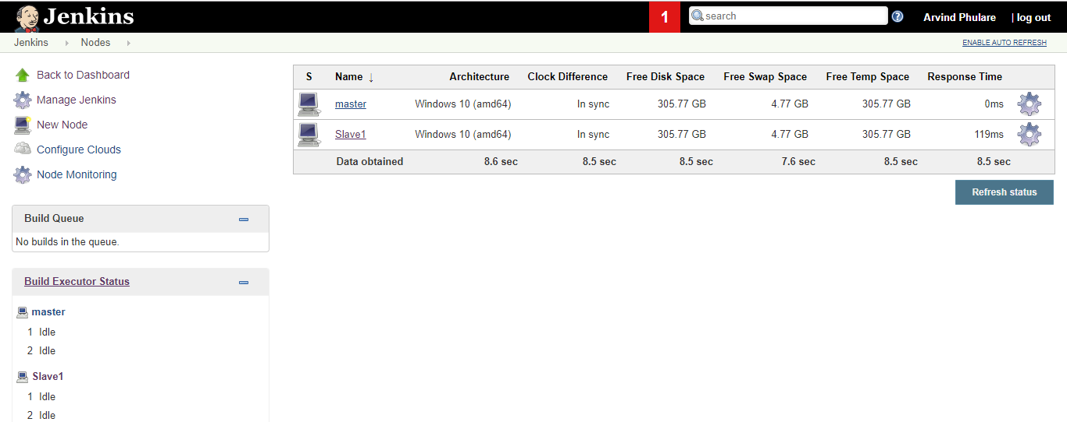
5. Now since your slave is up and running, lets execute a job on slave.
Demonstrate continuous integration and development using Jenkins.
DESCRIPTION Continuous Integration (CI) and Continuous Development (CD) are important practices in software development that can be achieved usingJenkins. Here's an example of how you can demonstrate CI/CD using Jenkins:
Create a simple Java application:
• Create a simple Java application that you want to integrate with Jenkins.
• The application should have some basic functionality, such as printing "Hello World" or performing simple calculations. Commit the code to a Git repository:
• Create a Git repository for the application and commit the code to the repository.
• Make sure that the Git repository is accessible from the Jenkins server.
Create a Jenkins job:
• Log in to the Jenkins web interface and create a new job.
• Configure the job to build the Java application from the Git repository.
• Specify the build triggers, such as building after every commit to the repository.
Build the application:
• Trigger a build of the application using the Jenkins job.
• The build should compile the code, run any tests, and produce an executable jar file.
Monitor the build:
• Monitor the build progress in the Jenkins web interface.
The build should show the build log, test results, and the status of the build.
Deploy the application:
• If the build is successful, configure the Jenkins job to deploy the application to a production environment.
• The deployment could be as simple as copying the jar file to a production server or using a more sophisticated deployment process, such as using a containerization technology like Docker.
Repeat the process:
• Repeat the process for subsequent changes to the application.
• Jenkins should automatically build and deploy the changes to the production environment. This is a basic example of how you can use Jenkins to demonstrate CI/CD in software development. In a real-world scenario, you would likely have more complex requirements, such as multiple environments, different types of tests, and a more sophisticated deployment process. However, this example should give you a good starting point for using Jenkins for CI/CD in your software development projects.
CREATE A JOB :

